**Principles of AI Surprise Test-2.1**

***Name:-*** *Sahil Kaundal* ***UID:-*** *21BCS8197*

***Sem.:-*** *4th* *Sem.* ***Section/Group:-*** *807/B*

***Subject:-*** *Principles of AI* ***Subject Code:-*** *20CST-258*

**Q1. State Representation of facts in predicate logic with an example.**

**Answer.**

Terms represent specific objects in the world and can be constants, variables or functions.

Predicate Symbols refer to a particular relation among objects.

Sentences represent facts, and are made of of terms, quantifiers and predicate symbols.

Functions allow us to refer to objects indirectly (via some relationship).

Quantifiers and variables allow us to refer to a collection of objects without explicitly naming each object.

Predicates: Brother, Sister, Mother, Father

Objects: Bill, Hillary, Chelsea, Roger

Facts expressed as atomic sentences a.k.a. literals:

Father(Bill,Chelsea)

Mother(Hillary,Chelsea)

Brother(Bill,Roger)

Father(Bill,Chelsea)

**Example:**

Marcus was a man  
• Marcus was a Pompeian  
• All Pompeians were Romans  
• Caesar was a ruler.  
• All Romans were either loyal to Caesar or hated him.  
• Everyone is loyal to someone.  
• Men only try to assassinate rulers they are not loyal to.  
• Marcus tried to assassinate Caesar

Predicate Logic Knowledgebase

Man(Marcus)  
Pompeian(Marcus)  
**∀** x Pompeian(x) 🡪 Roman(x)

 Ruler(Caesar)

**∀** x Romans(x) 🡪 Loyalto(x,Caesar) v Hate(x,Caesar)

**∀** x **∃**  y Loyalto(x,y)

**∀** x **∀** y Man(x)  **∧** Ruler(y) **v** Tryassassinate(x,y) 🡪 Loyalto(x,y)

Tryassassinate(Marcus,Caesar)

**Q2. Write short notes on Forward chaining and explain with example.**

**Answer.**

Forward chaining is also known as a forward deduction or forward reasoning method when using an inference engine. Forward chaining is a form of reasoning which start with atomic sentences in the knowledge base and applies inference rules (Modus Ponens) in the forward direction to extract more data until a goal is reached.

The Forward-chaining algorithm starts from known facts, triggers all rules whose premises are satisfied, and add their conclusion to the known facts. This process repeats until the problem is solved.

**Properties of Forward-Chaining:**

* It is a down-up approach, as it moves from bottom to top.
* It is a process of making a conclusion based on known facts or data, by starting from the initial state and reaches the goal state.
* Forward-chaining approach is also called as data-driven as we reach to the goal using available data.
* Forward -chaining approach is commonly used in the expert system, such as CLIPS, business, and production rule systems.

**Example:**

**"As per the law, it is a crime for an American to sell weapons to hostile nations. Country A, an enemy of America, has some missiles, and all the missiles were sold to it by Robert, who is an American citizen."**

Prove that **"Robert is criminal."**

* It is a crime for an American to sell weapons to hostile nations. (Let's say p, q, and r are variables)  
  **American (p) ∧ weapon(q) ∧ sells (p, q, r) ∧ hostile(r) → Criminal(p)       ...(1)**
* Country A has some missiles. **?p Owns(A, p) ∧ Missile(p)**. It can be written in two definite clauses by using Existential Instantiation, introducing new Constant T1.

**Owns(A, T1)             ......(2)**  
**Missile(T1)             .......(3)**

* All of the missiles were sold to country A by Robert.

**?p Missiles(p) ∧ Owns (A, p) → Sells (Robert, p, A)       ......(4)**

* Missiles are weapons.

**Missile(p) → Weapons (p)             .......(5)**

* Enemy of America is known as hostile.

**Enemy(p, America) →Hostile(p)             ........(6)**

* Country A is an enemy of America.

**Enemy (A, America)             .........(7)**

* Robert is American

**American(Robert).             ..........(8)**

## Forward chaining proof:

**Step-1:**

In the first step we will start with the known facts and will choose the sentences which do not have implications, such as: **American(Robert), Enemy(A, America), Owns(A, T1), and Missile(T1)**. All these facts will be represented as below.

Forward Chaining and backward chaining in AI

**Step-2:**

At the second step, we will see those facts which infer from available facts and with satisfied premises.

Rule-(1) does not satisfy premises, so it will not be added in the first iteration.

Rule-(2) and (3) are already added.

Rule-(4) satisfy with the substitution {p/T1}, **so Sells (Robert, T1, A)** is added, which infers from the conjunction of Rule (2) and (3).

Rule-(6) is satisfied with the substitution(p/A), so Hostile(A) is added and which infers from Rule-(7).

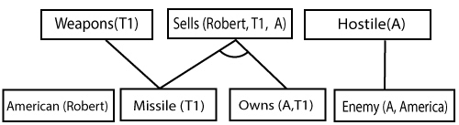

**Step-3:**

At step-3, as we can check Rule-(1) is satisfied with the substitution **{p/Robert, q/T1, r/A}, so we can add Criminal(Robert)** which infers all the available facts. And hence we reached our goal statement.

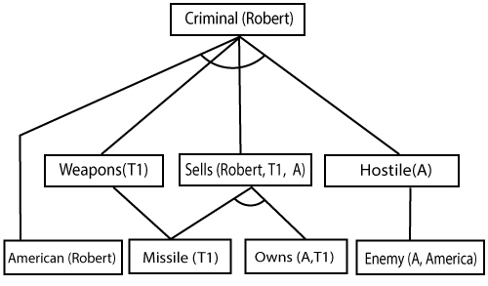

**Hence it is proved that Robert is Criminal using forward chaining approach.**